**FLOWCHART**

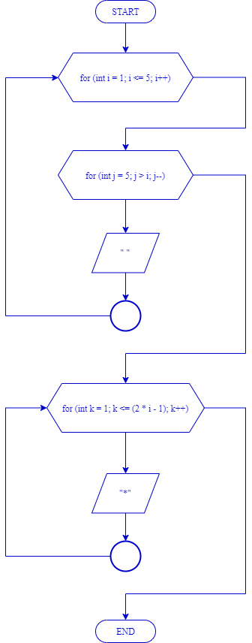

**SOURCE CODE**

**#include <iostream>**

**using namespace std;**

**int main () {**

**int n;**

**cout << "--------------------------- " << endl;**

**cout << "| Looping Segitiga Bintang |" << endl;**

**cout << "----------------------------" << endl;**

**cout << endl << endl;**

**for (int i = 1; i <= 5; i++) {**

**for (int j = 5; j > i; j--) {**

**cout << " ";**

**}**

**for (int k = 1; k <= (2 * i - 1); k++) {**

**cout << "*";**

**}**

**cout << endl;**

**}**

**return 0;**

**}**

**HASIL PROGRAM**

